**Eco-conscious consumption: Virtue signaling in the 21st century**

1

Sania Kharshingkar 2

***Abstract.*** Eco-conscious consumption can be understood as a modern form of virtue signaling. This paper discusses the phenomenon using four examples: tote bags, paper straws, thrifted clothing, and sustainable clothing. Each section delves into each product’s history, modern relevancy, its general sustainability and eco-friendliness. When looking into the relative ecological impact each product has, it can be observed that each “sustainable” product has an even more sustainable alternative practice, that less consumers partake. From those examples, I conclude that the driving force behind the popularity of eco-conscious products today is fueled by virtue signaling, rather than a genuine concern for the environment.

__________________________

1 I gratefully acknowledge my family for reading and reviewing this paper, as well as the professor who guided me through the process of writing.

2 Fremont CA, sania.kharsh@gmail.com

**Table of Contents**

1. Introduction …………………………………….………Pg. 3

2. Signaling: a brief introduction and review…….....……..Pg. 3

3. Examples of eco-conscious virtue signaling..………......Pg. 4

3.1 Tote Bag………………………………..…………...Pg. 4

3.2 Paper Straws………………………...………………Pg. 5

3.3 Thrifted Clothing……………………………………Pg. 6

3.4 Sustainable clothing…………………………………Pg.7

4. Discussion and Conclusion

References

**1.Introduction**

**“A man when he has done a good act, does not call out for others to come and see, but he goes on to another act, as a vine goes on to produce the grapes in season.” - Marcus Aurelius**

With the rise in concern and public knowledge about ecological issues such as the climate crisis and pollution, there has been a wave of new products designed to benefit the environment as well as the daily consumer. In a massive shift of attitude from decades before, many people today tend to take pride in their efforts to reduce waste and pollution, and this is often done through the purchasing of products marketed as ecologically conscious. I had begun to take notice of the impact the popularization of eco-conscious products had on my own life, with the appearance of metal straws in my kitchen cabinets and reusable tote bags in my closet. Over the course of the 21st century, occasional eco-conscious purchasing has become the expected norm of common consumers. I was aware of this fact whenever I was on any social media app, as random posts from outfit pictures to craft videos would have their comment sections filled with the scrutiny of thousands of people arguing that the clothing in the post was from a fast fashion brand, or that the materials used in the crafting post was non-biodegradable. Every time I would check the comments of any miscellaneous post, there would be an argument taking place over the ethics of buying from the particular brand of a product that was visible in a video, or the accessibility of sustainable products to the poor. It was fascinating to observe how aggressive the general public had become in terms of dealing with those who weren’t fitting into their ideal of sustainability. On the same side of that issue, I witnessed how people could develop a superiority complex over the actions they took to promote ecological sustainability, especially based on the select products they would purchase. Many products that would be flaunted in Instagram posts for their sustainability also tended to be expensive luxury items, like clothing from high end brands or electric cars like the Tesla. Despite the emphasis that consumers placed on the ecological benefits of those products, it was also plainly visible that most were attracted to the product because of its high status in the public.

**2. Signaling: A brief introduction and review**

In a general sense, the term “signaling” is defined as transmitting information or instructions by means of a gesture, action, or sound. In economics however, signaling is used in a two-player system. In this case, signaling is the idea that one party (termed the agent) credibly conveys some information about itself to another party (the principal) usually by means of costly action. For example, if a car brand wants to convey the idea to the consumer market that its cars are high quality, it would employ marketing tactics to signal the fact that their car is desirable to the general consumer. In this example, the car brand is the agent, and it wants to signal its worth to the consumer, the principal. This method of signaling is discussed in the terms of companies and consumers, but a common type of signaling seen in society is virtue signaling, where individuals will try to display that they are virtuous to others around them. This could be in the form of donating to a charity publicly, or doing superficial volunteer work. Some historical examples of virtue signaling include church indulgences, the organization of large prayers by the rich, and mission trips to developing countries. The methods of virtue signaling throughout history can be varied, due to the significant shifting of approved “virtues” in societies. The specific types of virtue signaling being focused on in this paper are the superficial acts of ecological sustainability prevalent in today’s world.

**3. Examples of eco-conscious virtue signaling**

**3.1 Tote Bag**

**Figure 1 - The figure shows the percentage of words identified as “tote bag” in written works transcribed to Google from the years 1900-2019**

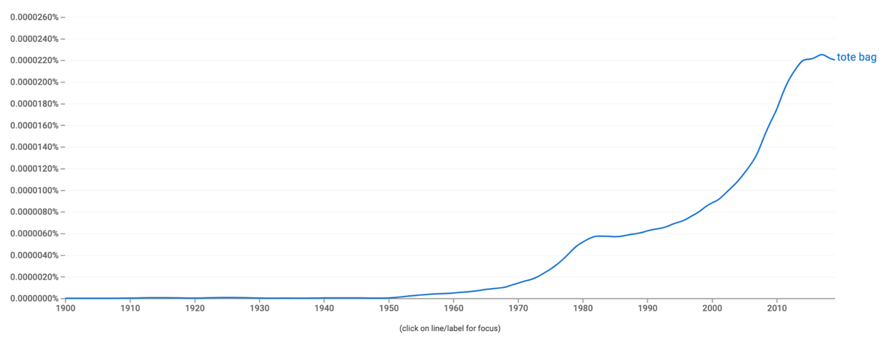

Tote bags were first introduced to the mainstream markets in the 1940’s, produced by the company L.L. Bean in the form of an ice bag (Purvis, 2019). The ice bag had a boxy structure made of canvas, built to carry ice from the customers car to the freezer. The design became largely popular in the 1950’s and was regarded as the staple utility bag by homemakers, who utilized it for grocery shopping and chores. L.L. Bean upgraded the famous tote bag design in the 1960’s, where it gained popularity in the fashion market for being fashionable as well as functional. The tote bag continued to shift while staying true to its unique trademark design, making it a staple in American families. In the 21st century however, the tote bag has garnered a new meaning and reason for its use. With the rise of ecological sustainability, many retailers announcing their goal to reduce plastic in the form of charging for single-use shopping bags, many eco-conscious consumers turned to the tote bag as a reusable bag to combat the single use plastics. The common statistic used to market tote bags for sustainability was that one reusable bag had a lifespan equal to 700 disposable bags (ReTweed, 2019). As a result of its sustainable reputation and low overall cost, the tote bag has become a symbol of eco-conscious consumption among many families today. Many see the value of the tote bag as a useful shopping tool, but also as a method of showing others their contribution to sustainability. The complications arise, however, when the resources used to produce tote bags and plastic bags are compared. According to research, reusing a single plastic bag three times has the same environmental impact as using a cotton tote bag 393 times (​​Krosofsky, 2021). This is due to the copious amount of resources and waste used to produce a single tote bag compared to a plastic bag. A study *(Life cycle assessment of supermarket carrier bags: a review of the bags available in 2006, 2006)* discovered that when accounting for the production and overall transportation of tote bags, the composite carbon footprint came to 598.6 pounds of CO2. The standard HDPE bag, on the other hand, emits 3.48 pounds. This large disparity between the carbon emissions, the amount of resources, and the amount of waste created reveals the tote bag as a false sustainable measure. In fact, many ecology researchers have concluded that the best course of action would be to reuse plastic bags many times, rather than purchasing tote bags and replacing them continuously. The question that comes to mind when faced with such facts, is whether or not the average “eco-conscious” consumer would give up their usage of the decorated tote bag and switch to using one plastic bag over and over again. One thing that can be inferred from many examples of sustainability virtue signaling, is that most of the signaling is tied to how big of a perceived inconvenience the person goes through to help the environment. In the case of tote bags, the main inconvenience is that the bag has to be carried around at all times, whereas with plastic bags, they can be purchased on-site at the store whenever a person makes a purchase. If someone were to be carrying around a tote bag with the desire to show others how eco-conscious they are, they might pull the bag out in the middle of a grocery line and talk about how it was a hassle to carry the bag around but they do so to reduce the usage of plastic bags. When the waste garnered by the production of tote bags is taken into consideration, it turns out that use of tote bags is more environmentally damaging than continually re-using plastic bags. Thus, if consumers were genuinely motivated by environmental concerns, they would take one plastic bag and continually reuse it instead of buying brand new tote bags. Therefore, using tote bags is best understood as virtue signaling rather than genuine concern for the environment.

**3.2 Paper Straws**

**Figure 2 - The figure shows the percentage of words that were identified as either “plastic straws” or “paper straws” in written works transcribed to Google from the years 1900-2019**

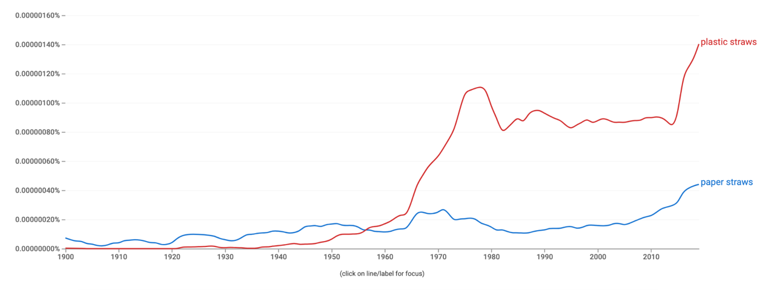

Paper Straws were once considered the standard form of straws before the invention of plastic straws, but in today’s wave of eco-conscious consumption, paper straws have begun to return. In the beginning of the 19th century, the modern straw’s predecessor was created using either wheat or rye. The rye straws however, had a reputation of leaving a grassy aftertaste and becoming soggy, making them unpopular with the general public. The first modern straw to become popular with the market was a paper straw, invented by Marvin Chester Stone. He filed the patent for his paper straws in 1888, and marketed it directly to companies to gain bulk sales, and to popularize it among individual consumers (Tembo Paper, 2021). The invention of plastic straws in the 1950’s came after Stone’s paper straws, and took the market by storm seemingly overnight (Tembo Paper, 2021). The growth of fast-food restaurants greatly contributed to the popularization of plastic straws, and it soon became the staple version for consumers across the world. In the 21st century, the reign of the plastic straw has come under heavy criticism due to the large amount of plastic waste it has left in landfills. Many consumers took notice of the negative effect the plastic straws have had on the environment, specifically in the ocean, and searched for an alternative. This caused the resurgence of paper straws, the original version, into the market. Just like the plastic straws, the new wave of paper straws was greatly publicized by large companies. McDonald’s began by introducing paper straws in the UK and Ireland branches, completely phasing out plastic straws (Vaughan, 2018). Many other fast food chains began following suit, and consumers began to take notice of the trend. Paper straws soon became the poster child for basic eco-conscious consumption, taking over many other retailers such as Starbucks, Jamba juice, and local drink stores. When implementing paper straws, many retailers came across the issue that the straws were not being recycled as they had been contaminated by the liquids from the drinks sipped through the straw. This resulted in them being dumped directly into the landfill, defeating the main purpose of the straws in the first place (Latten, 2020).  The most reasonable course of action after being presented with these facts would be to reduce the usage of straws completely, or carry around portable reusable straws made of glass or metal. There is still a long way to go before single - use straws become the minority, but the purchase of reusable portable straws has become more commonplace after its popularity on social media (WasteWise. 2019). If the majority of eco-conscious consumers take true sustainability into account, we can expect this number to increase.

**3.3 Thrifted Clothing**

**Figure 3 - The figure shows the percentage of words that were identified as “thrifting” in written works transcribed to Google from the years 1900-2019**

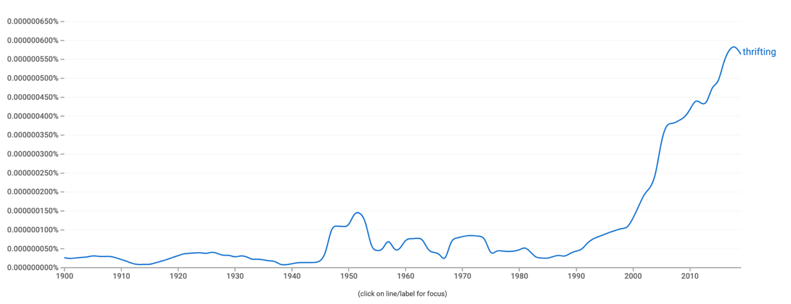

Thrift shopping has historically been the main practice of people in poverty or otherwise on tight budgets, however a rise in eco-conscious thinking and the tempting price tags of second-hand goods has caused more people to begin thrift shopping, regardless of their financial situation. Both the appeal of the activity and the gold-star reputation of being ecologically sustainable has contributed to thrifting’s rise in popularity in those who are not confined by their budget. Thrift shopping had started out as a practice for those who needed an inexpensive option to store-bought clothing. It was commonly thought of as something shameful to be seen in, until its resurgence in the late 2010’s as a unique and sustainable way of building a wardrobe. According to a report by resale service ThredUp (an online thrifting store) In 2019, around 40 percent of young adults were buying second hand, compared to less than 30 percent in 2016 (Nguyen, 2021). The eco-conscious reasoning behind the shift towards thrifting is that buying previously owned stuff keeps products in circulation for longer, making the practice beneficial to the environment. It has been shown time and time again that buying secondhand clothing is a direct counter to the rise of fast fashion, a form of clothing production that has often fallen under criticism for its lack of sustainability and morality, but it's sudden prevalence in today’s trending activities might prove harmful for other communities in the long run. Scientists, environmentalists, and urban planners have come to realize over the years that some trendy sustainable practices could actually be harmful to marginalized people. In the case of thrifting—when you consider the current price hikes in many thrift stores, it is a direct result of the high demand for thrifted clothing. In certain thrifting locations within large cities, prices have already begun to rise at a significant margin, putting at a disadvantage the poorer people who were at first considered the target market. It has become commonplace to see resellers go to thrift stores and buy cheap clothing for bulk, and then resell them on their website for 3x more the initial price (Nguyen, 2020). Taking all of this controversy into consideration, many have correctly identified the most effective way to reduce clothing waste on the planet: buying less clothes. Although it seems like a simple solution, it is not one that many take seriously, considering how the average American today buys “68 articles of clothing per year” (Thomas, 2019).

**3.4 Sustainable Clothing**

**Figure 4 - The figure shows the percentage of words that were identified as “sustainable clothing” in written works transcribed to Google from the years 1900-2019**

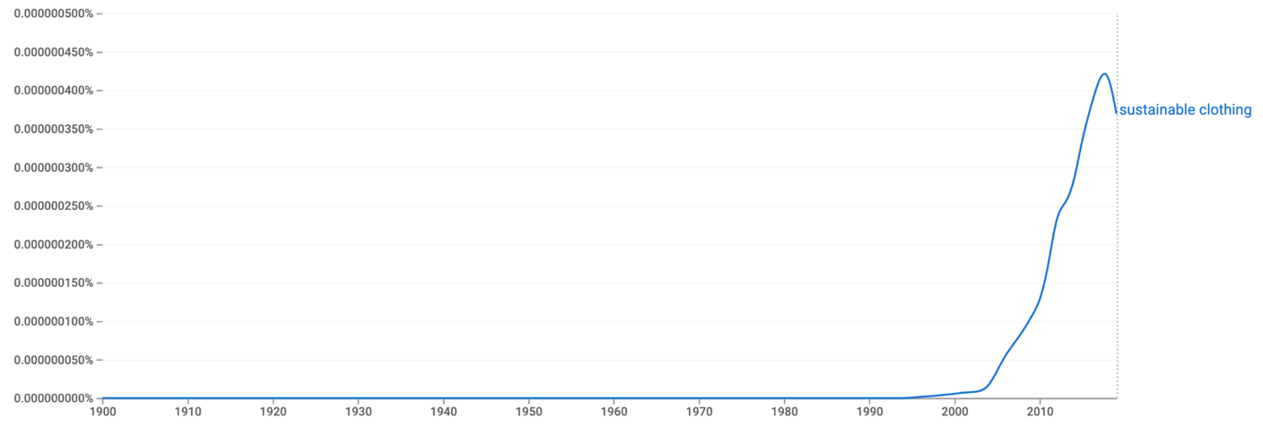

Sustainable clothing is often hailed as the modern-day solution to basic waste, as it is usually defined as “garments that have been made in a way that is mindful of the many environmental issues the fashion industry touches upon ''. This definition covers a wide range of practices such as making clothing from fabric scraps left by factories, making clothing from biodegradable fabric, or producing clothing in ethical factories where workers are paid living wages. Sustainable clothing has become a forefront on the “war” against fast fashion brands and their unethical, wasteful practices. Promotion of sustainable clothing brands has become commonplace on social media sites, especially in response to the rise in fast fashion. One of the most popular sustainable clothing brands today, Reformation, has made sustainability their tagline to make headway in the fashion world. The New Yorker described the brand as having “a slightly cultish following, was known for minimalist, insouciant dresses … designed for the bodies of models, produced from environmentally friendly fabrics, and mostly priced in the low three digits. The problem arising with sustainable clothing has become the sheer amount being purchased, rather than what’s being recycled. In one aspect, many stores marketing clothing made of recycled fabrics have been known to use pre-production fabric, meaning that fabric being used is sourced before any scrap is accumulated. In addition, the average American buys 64 pieces of clothing per year. Combined with the large population, it is obvious how overconsumption has become a beast not even sustainable, expensive clothing can defeat.

**4. Discussion and Conclusion**

It has become apparent that the practice of virtue signaling is nothing new - from the indulgences of the 15th century church, to the overtly publicized charity donations today. What has become a forefront of the consumer experience can be described as virtue signaling for the modern-day middle class, also known as eco-conscious consumption. Over the course of the sustainability movement in America and other countries, the dominance of the products being used by the general public seem to be products that successfully put on the appearance of being sustainable, while not actually being the most sustainable option. Starting with the daily examples I see of battles between certain consumers to be the most ecologically sustainable, to the large-scale consumer trends of buying well marketed products that give the illusion of sustainability, the future of the product market is set to be increasingly influenced by the practice of sustainable consumption. It can be inferred that businesses in the future will be encouraged to participate in the trend of partaking in ecologically sustainable practices and heavily advertising their contribution to sustainability. However, shown by the tendency of consumers to prefer virtue-signaling products that are popular rather than products or practices that are less known but more sustainable, I can foresee a rise in exaggerated or fake claims made by businesses for sustainability.  The best course of action from here on out is to implement proper marketing for *true* sustainable practices rather than half-hearted products. An example of this was given previously in the section on paper straws, as many consumers are now starting to popularize the usage of reusable metal and glass straws rather than single use plastic and paper straws. This is a positive change considering that using reusable straws is the best method of eliminating waste in the environment. Another solution to this issue includes the spreading of information on true sustainable practices and methods, and the checking of trust marks on products. The most relevant trust mark for this is called the Green-E Trustmark, which is administered by the CRS (Center for Resource Solution). This trust mark verifies that a product is made with the most sustainable methods possible, and assures consumers they are purchasing products that have actual contributions to sustainability. Until these measures are taken, the trend of eco-conscious virtue-signaling will continue to grow.

**References**

1. ​​Krosofsky, Andrew. “How Do Reusable Grocery Bags Help the Environment?” *Green Matters*, Green Matters, 1 Mar. 2021, https://www.greenmatters.com/p/reusable-grocery-bags-help-environment
2. Latten, Bas. “Paper Straws: Are They Really as Eco-Friendly as We Think They Are?” *Straws*, ECO Wheat - Straws, 9 Dec. 2020, https://wheat-straws.com/blogs/news/paper-straws-are-they-really-as-eco-friendly-as-we-think-they-are.
3. Muthu, Subramanian Senthilkannan, and Yi Li. “Life Cycle Assessment of Grocery Shopping Bags.” *Assessment of Environmental Impact by Grocery Shopping Bags*, 2013, pp. 15–54., https://doi.org/10.1007/978-981-4560-20-7_3.
4. Nguyen, Clinton. “Here's How Many Times You Have to Use a Tote Bag for It to Actually Be Environmentally Friendly.” *Business Insider*, Business Insider, 8 Sept. 2016, https://www.businessinsider.com/tote-bags-sustainability-environmental-impact-2016-9#:~:text=The%20study%20found%20that%20the,a%20standard%20plastic%20HDPE%20bag.&text=The%20standard%20HDPE%20bags%20had,are%20needed%20to%20make%20them.
5. Nguyen, Terry. “How Thrifting Became Problematic.” *Vox*, Vox, 26 Apr. 2021, https://www.vox.com/the-goods/22396051/thrift-store-hauls-ethics-depop.
6. ReTweed. “History of Tote Bag.” *ReTweed*, 7 Oct. 2019, https://www.retweed.com/2019/10/a-short-history-of-the-tote-bag/history-of-tote-bag/.
7. Tembo Paper. “A History of Paper Straws.” *Tembo Paper*, 8 Apr. 2021, https://www.tembopaper.com/news/history-of-paper-straws#:~:text=Stone%20filed%20the%20patent%20for,hemp%20originating%20from%20the%20Philippines.
8. Thomas, Dana. “The High Price of Fast Fashion.” *The Wall Street Journal*, Dow Jones & Company, 29 Aug. 2019, https://www.wsj.com/articles/the-high-price-of-fast-fashion-11567096637.
9. Tolentino, Jia. “Virtue and Vanity at Reformation.” *The New Yorker*, 1 Nov. 2019, https://www.newyorker.com/culture/on-and-off-the-avenue/virtue-and-vanity-at-reformation.
10. Written by ToteBagFactory — September 20, ToteBagFactory. “History of the Tote Bag.” *History of the Tote Bag, Canvas Tote Bags, Canvas Bags*, https://totebagfactory.com/blogs/news/history-of-the-tote-bag.
11. Vaughan, Adam. “McDonald's to Switch to Paper Straws in UK after Customer Campaign.” *The Guardian*, Guardian News and Media, 15 June 2018, https://www.theguardian.com/business/2018/jun/15/mcdonalds-to-switch-to-paper-straws-in-uk-after-customer-concern.
12. WasteWise. “Are Reusable Straws Becoming More Popular as Single-Use Plastics Are Banned?” 2019 *Waste Wise Products Inc.*, https://www.wastewiseproductsinc.com/blog/plastic-pollution/are-reusable-straws-becoming-more-popular-as-single-use-plastics-are-banned/.