Classifying Fish using Convolutional Neural Networks

Aarush Mehta

August 16, 2022

Abstract

Machine learning is a powerful tool which can be used to accomplish many different tasks. Through the use of machine learning, specifically with the use of convolutional neural networks, we are able to accurately classify large datasets of images. In this article, we will use convolutional neural networks in order to conduct multi-classification on a dataset containing many images of a variety of different fish.

1 Introduction
Using Machine Learning, we are able to create as well as train models that can be used to make predictions or classifications of data that it has been trained to make these predictions on. In this case we are using supervised learning in order to train our data by pairing the correct labels with each image in the dataset to train the model on identifying the correct label when given . The goal of this instance of supervised learning is to create a model that will be able to correctly classify images outside of the dataset it is trained with. The data set that is being considered consists of 1000 images of 9 different varieties of fish taken in a supermarket in Izmir, Turkey. Depicted below in Table 1 is an example of some of the fish used , and their given classifications.

Image | Classification
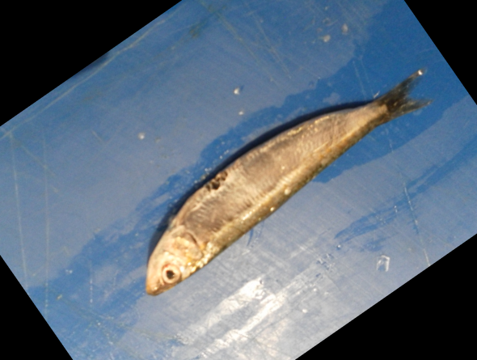 | Black Sea Sprat
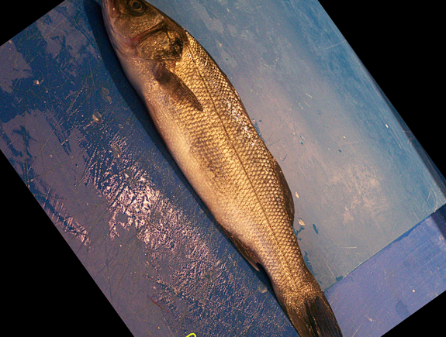 | Sea Bass
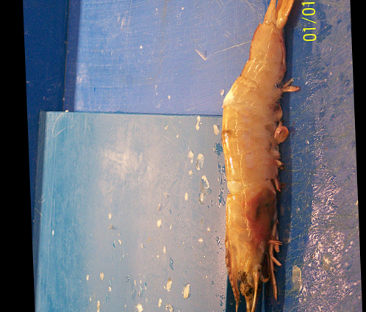 | Shrimp
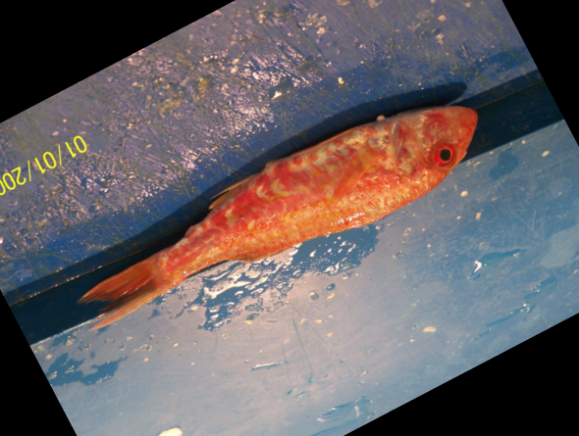 | Red Mullet

Table 1 : An example of our data set.

In this case, the goal of the learning is for the model, once developed, to be able to classify new pictures outside of the existing dataset correctly as the .
In Section 2, we will be explaining what a multi-classification problem such as this one is. In Section 3, we will describe convolutional neural networks, and specifically what we used in this article. In section 4, we will be analyzing the results we achieve with our model. In section 5 we will be ending the article with a conclusion.

2 Multi-Classification Problems
In the dataset being used for this article, each fish belongs to one of 9 different categories: Black Sea Sprat, Gilt-Head Bream, Horse Mackerel, Red Mullet, Red Sea Bream, Sea Bass, Shrimp, Striped Red Mullet meaning that the model will be trained to classify within these 9 categories. Due to the amount of classifications that can occur, problems like these are called multi-classification problems.
Multi Classification problems assume that each entity can only represent one of the different categories. In this situation, no single fish can be more than one type. While training, the model is able to identify features that are distinct to each fish and use those features to determine which singular label fits with each image.
For Multi-Classification problems, the features of the data is inputted, and the output is a list of numbers for example if there were nine different possible classifications the list would look like : $\hat{y}= \left[\hat{y}1,\hat{y}2,\hat{y}3,\hat{y}4,\hat{y}5,\hat{y}6,\hat{y}7,\hat{y}8,\hat{y}9\right].$ In this list, $\hat{y}$1,$\hat{y}$2,$\hat{y}$3,$\hat{y}$4$\hat{,y}5,\hat{y}6,\hat{y}7,\hat{y}8,$ and $\hat{y}9$ have a sum of 1 as $\hat{y}$ is equal to the probability that the data is of a certain classification.
An example of this in the context of our model is the equation : $\hat{y} = [0.1,0.15,0.15,0.05,0.025,0.075, 0.25, 0.02, 0.18]$ with 0.25 representing a 25% probability of the fish being a shrimp being the highest probability the image would be classified by the model as being a shrimp.

3 Neural Networks

Using neural networks, we aim to create a model or a function that is able to take images, and the data that can be found in images such as different features in the image and outputs a list $\hat{y}$. As shown before, the list $\hat{y}$ aims to predict using the data given the classification which has the highest probability of being correct. In the context of this article the data given is the specific features of images and the resulting $\hat{y}$ will be the classification that the model determines the features of the image best represent.
The function or model used to make our predictions is known as a neural network. Specifically in this instance, we will be using a convolutional neural network. A convolutional neural network is most commonly used for processing pixel data and is distinguished for its superior performance with image related tasks.
Each neural network is made with a different architecture which consists of many things. Layers are different functions which are arranged sequentially to form the network. The first layer of the sequence is called the input layer while the last layer is called the output layer. The input of the input layer is X, and once it passes through each layer (function) the output layer outputs $\hat{y}$ as the prediction the network makes.
There are many types of layers which can be used in conjunction to form a network,
However, in this particular instance we are using convolutional, max pooling, dense, and dropout layers all of which are able to offer different benefits to creating one cohesive network to successfully classify the images of fish. Each layer contains the following:

- Hyperparameters which are able to adjust the amount of parameters and thus the complexity of the model.
  - The more complexity the model contains, the smaller the error of the training set will be leading to a more accurate prediction on the training set.

  - At an ideal level, the right amount of complexity in the model can lead to optimal results when the validation set is tested.

  - If the complexity is too high this can lead to what is known as overfitting which can cause the error in the validation set to increase.

  - The dropout layer we use is a way to assist in suppressing overfitting that is occurring in the network.

- Each layer in a neural network uses an activation function to determine the nature of the layer

Once we have determined the architecture of our network we will develop the model. In order to do so first the data must be split up into two sets : a training dataset as well as a validation dataset. The training dataset is what the model will be developed off of to ensure that the error on the training set is as low as possible to ensure optimal accuracy. Using the Keras library in Python, we are able to find the optimal parameters for our network that result in our error to be the lowest, and our model is ready to be tested

4 Analyzing Results

Our training set consisted of 9000 images - 1000 of each type of fish. Our validation set consisted of 1800 images - 200 of each type of fish. After trying many different architectures, the architecture that we have found to work the most optimally contains:

- The first layer is a convolutional layer with 16 filters, a filter size of $f = 3$, no padding added, and relu as the activation function.

- The second layer is another convolutional layer with 32 filters, a filter size of $f = 3$, no padding added, and relu as the activation function.

- The third layer is another convolutional layer with 64 filters, also using relu as the activation function.

- The data is then flattened, and connected to a dense layer with 64 nodes using relu as the activation function.

- A dropout layer with a rate of 0.4 is added to mitigate overfitting.

- This is connected to the output layer which uses 8 nodes and a softmax activation function

The Accuracy was recorded to be 99.94% on the training set and 96.23% on the validation set.

5 Conclusion

Machine learning is an extremely powerful tool which can be used for many different applications. In this article, we used neural networks to show how machine learning can be used in multi-classification problems and classify images in large datasets in an accurate manner employing different techniques to minimize error.

References

[1]Brownlee, Jason. “A Gentle Introduction to Dropout for Regularizing Deep Neural Networks.” Machine Learning Mastery, 6 Aug. 2019, https://machinelearningmastery.com/dropout-for-regularizing-deep-neural-networks/.

[2] By: IBM Cloud Education. “What Are Convolutional Neural Networks?” IBM, 20 Oct. 2020, https://www.ibm.com/cloud/learn/convolutional-neural-networks.

[3] Nabi, Javaid. “Machine Learning - Multiclass Classification with Imbalanced Data-Set.” Medium, Towards Data Science, 23 Dec. 2018, Nabi, Javaid. “Machine Learning - Multiclass Classification with Imbalanced Data-Set.” Medium, Towards Data Science, 23 Dec. 2018, https://towardsdatascience.com/machine-learning-multiclass-classification-with-imbalanced-data-set-29f6a177c1a.

