Supplementary Materials. Images

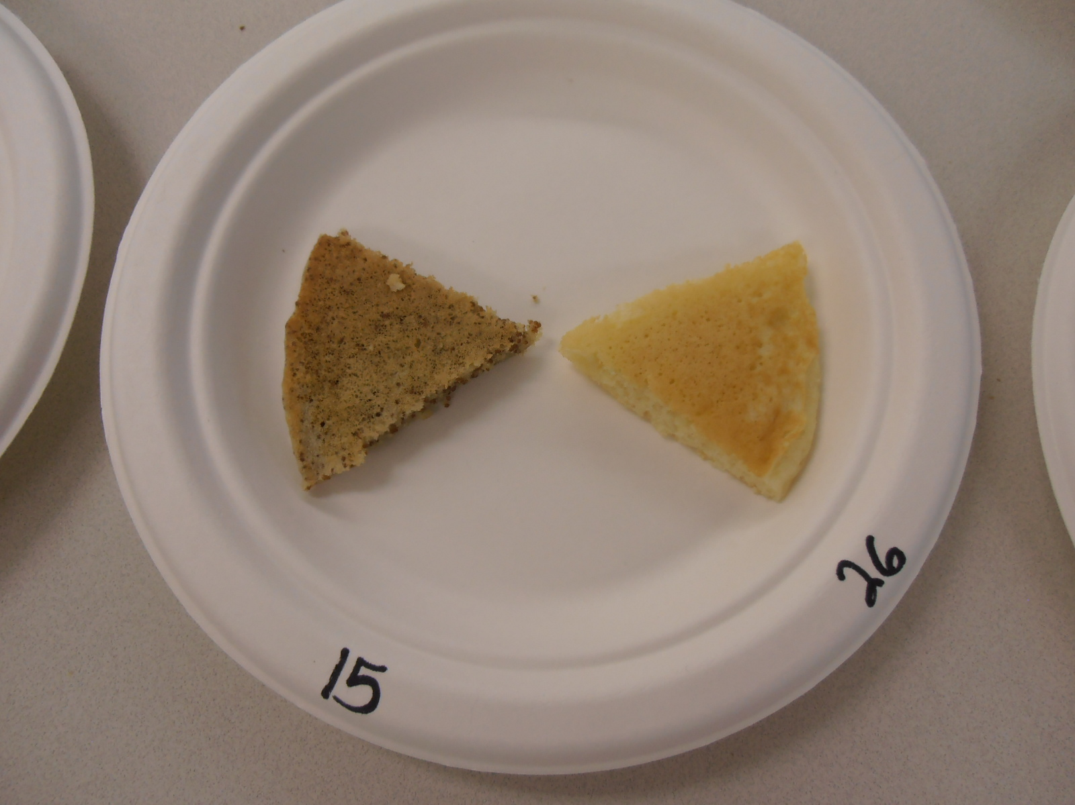
Image 1. Sample plate given to participants for sensory evaluation.

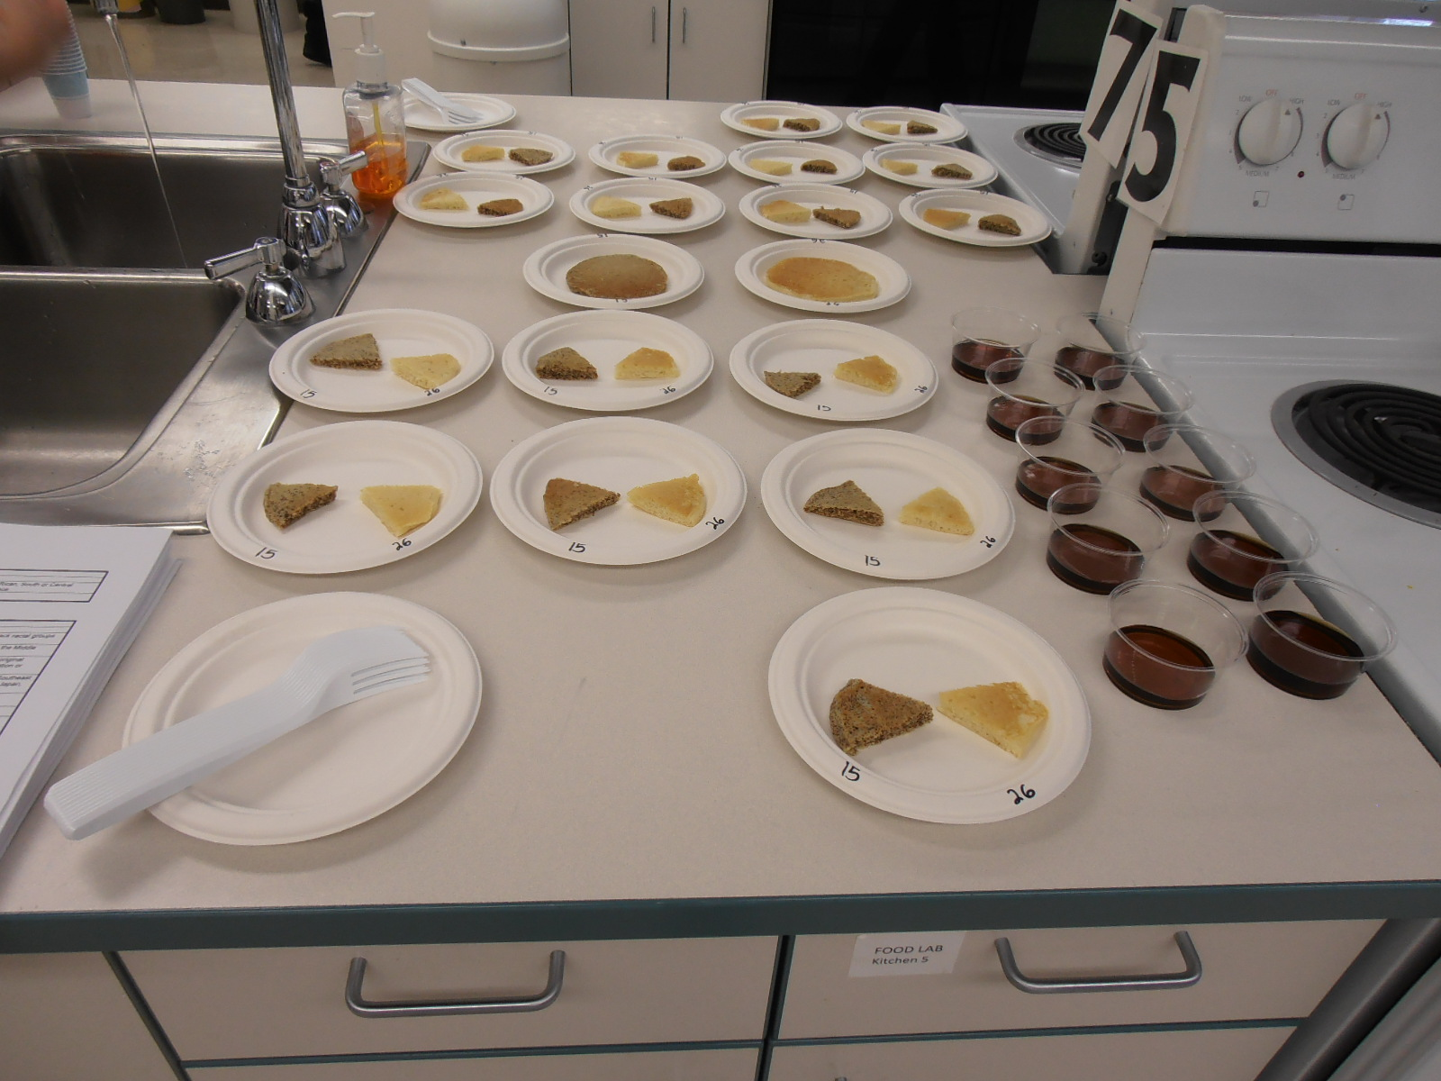
Image 2. Sensory evaluation set-up.

